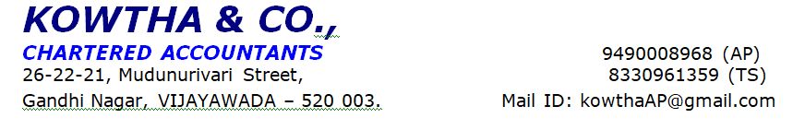
IDFC Bank LTD – Personal Discussion Report
I] General Details:-
Name of the Applicant | Mr.XXX
Name of the Co-Applicant/s | -
Reference Number | 504661838
Product | Self Employ
Customer Category | Partnership Business
Date of Initiation | 16-05-2025
Date of Customer Availability | 16-05-2025
Date of PD | 16-05-2025
Number of Visits Made | 01.
Person Met | Applicant.
Place and Address of Visit | XXX
Owned/ Rental | Rental
Whether Name Board Seen | Yes

II] Personal Details:-

Name of the Applicant | MrXX
Phone No. of the applicant | XX
PAN No. | Not provided
Educational Qualification | B.com
Role in Business | Active partner
Details of Family Members | XX-wife-35years-Degree-housewife  XXX-Daughter-11years-5th class-Student  XX-Son-9years-3rd class-Student  XXX -60years- Family Man  XXX -Mother-52years-Housewife
Residence Address | XXX
Nature of Residence | Rent
No. of years in the same address | 10years
No of years in the same City | By birth
Permanent Address (If different from above) | Guntur
Name of the co-applicants and relationship | XXX

III] Business/ Work Details:-

Name of the Entity/ Employer Name | M/s XXX
Constitution | Partnership
Brief on business model and Nature of Business | Making of Food
Year of Incorporation | 2016
Business actively managed by Self / Others: If others name and relationship with the applicant | All Partners
Number of years in Business/ Service | 09years
Total Work Experience | 09years
Business started by Self Or Family Business | Self
Previous Work Experience | NA
If the business entity is a Pvt. Ltd. then Name of the directors and their share holding | NA
Registered with Shop & Establishment act? if Yes Regn NO | GST

Business Data:
IV] Operational Details:-

Nature of Business / Line of activity | Making of Food
Relevant Experience/ Qualification | 09years
Describe Business Process | - Applicant and his partners started business in the name of M/s XXX from 2016 at Guntur  - It is Partnership business and partners are Applicant, XXXX and XXX and sharing equally  - Nature of business is making of food items  - He has running in visited address for last 4years  - He has 9years of experience in this field  - Applicant prepare 40types of food items in business like different types of chicken, Rotis, Mayonnaise, Burger, Shawarma and pickles and hot sauces etc.  - He makes all hot types food items and distributed to his all franchises all over AP and Telangana  - He provides franchises services to general public  - At present applicant has total 40franchises all over AP and Telangana  - He charges Rs.7lakhs to Rs.10lakhs for each Franchise  - He purchases required material from wholesale distributors  - Applicant running business in rental premises and He paying Rs.70,000/- per month  - 35employees are working in business and He paying Rs.5lakhs per month  - Applicant and his partners manage all business activities  - Business transactions are done through both cash and bank mode
Activity level at the time of visit | Good business activity seen at the time of visit
Details of Product | Making food items
Source of Raw Material
Names of Customers with contact No. | xxxx
Names of Suppliers with contact No. | Not provided
Employee Strength and Actual seen at the time of Visit | 35
Strengths and Weaknesses of Business | We observed good level of business active and equipment in business

V] Financial Details:-

Particulars | As per the data provided by the applicant up to 31-03-2025 | As per our estimation
Gross Income per year |  | 50,00,000/-
Net Income per year |  | Rs. 46,75,000/-
Net Profit for last 2 years | -
Gross Business Margin % | - | 20%
Net Business Margin % | - | 07%
No. of years filing ITRs | -
Last 2 years ITRs | - | -
Last 2 years Form 16 (Salaried) | - | -

Loans and Banking Details:
Term Loans:
Institution / Bank / NBFC Name | Type of Loan (LAP / HL / CD / CV / AL etc.) | Monthly Principal / EMI | Monthly Interest (if not in Emi mode) | Loan amount  Rs .Lacs | MOB | O/s  (Rs)
IDBI | HL | 70,000/- | 0 | 60lakhs | -
Union | OD |  | 1lakh | 1.04crores
Banking Details:
Bank Name | Type of Account | Relationship since | Avg balance
Union | OD | 1.5years
Other Assets:
- Nil

Other Business if any:
- -

Rental Income If any: -
- -

Property address | Tenant Name | Since When ( no of years ) | Rent agreement available ( Y / N ) | Monthly Rent amount? (inclusive of maintenance)
 | - | - | -

VI] Loan Details:-
Amount of Loan Applied | Rs. 1,50,00,000/-
Purpose of Loan (End Use) | Flat Purchase
Collateral Offered | Residential flat
Address of the Property offered as collateral | Pattabipuram,Guntur
Owner of the Property | NP
If the Property is Vacant, reason for the same | NA
Area of the Property (Sq. yd.) | 3200Sqft
Market Value of the Property (Approx) | NP
Is the property presently mortgaged with any Bank / FI? | No
If yes (provide the name of financier and loan details) | NA
End use of loan | Flat Purchase

VII] Personal Discussion Details:-
Strengths
Other observation | - GST  - GST Returns  - Bank Statement  - ITRS  - Food License
Overall outcome of the Personal Discussion | Good
Remarks | Positive
PD Conducted by  Signature  Date | xxxx  xxx

The details provided in the application form and the details provided by the customer at the time of discussion are same – Yes / No. (If NO please provide the details)

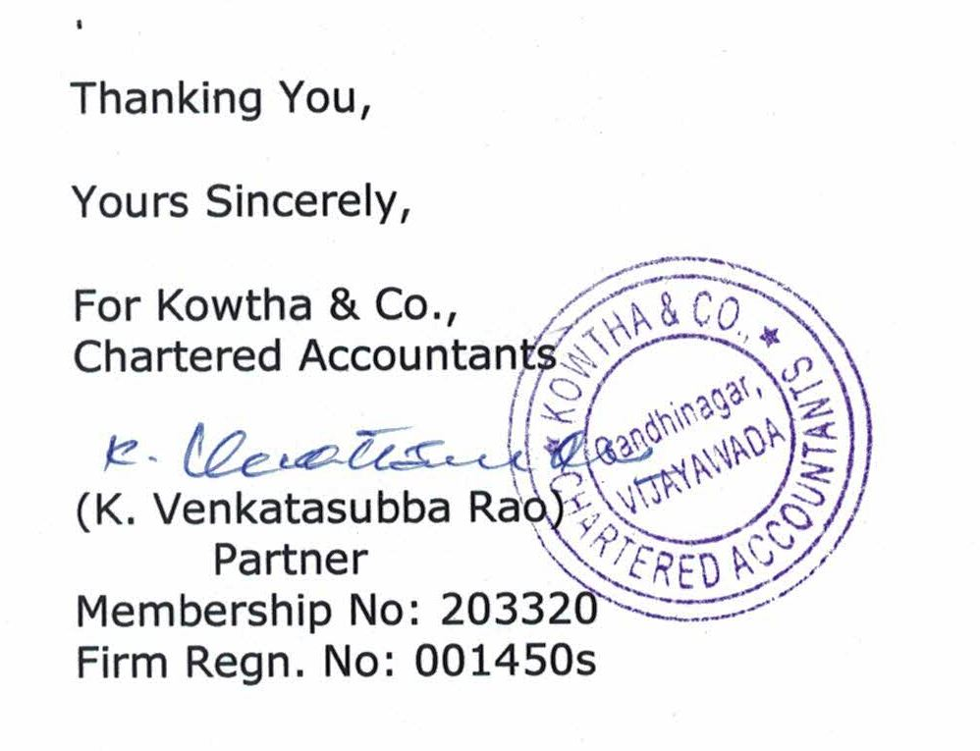

Photos:

